**Name: ZEINAB AHMED FAISAL TAWFIK**

**GROUP: P6 online**

**Instructor name: Ahmed Atia**

**Project description:**

The project is a smart home application based on Bluetooth where we control the home devices through a mobile application through Bluetooth

* 2 kits are used in this project one of them to be the master and the other one the slave.
* The master is the transmitter, and the slave is the receiver.
* The master which is the first microcontroller send the data by using Bluetooth module with UART protocol to the slave which is the second microcontroller with SPI protocol
* The data received through the SPI was to light on or of for the house device’s
* The project based on DIO layered architecture, SPI protocol (receiver), and UART (transmitter).
* the main. C is the file that control the operation of doing all the items at the same time (the app).
* Each microcontroller has a code to give the data to let the kit do the needed operation
* **Flowchart**
* **Start**
* Initialize Bluetooth
* Send the data from the 1st microcontroller through UART to the 2nd microcontroller through the SPI
* If the Checked data = 1
* Yes, led on
* No, End
* else if the checked data = 0
* Yes, led off
* No, End





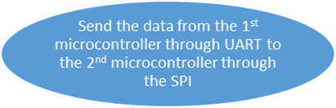



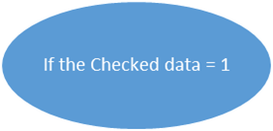



 yes

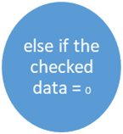



 no

no yes